**Keep It Simple**

Common Components

* Header
* User Login
* Nav Bar
* Footer Area

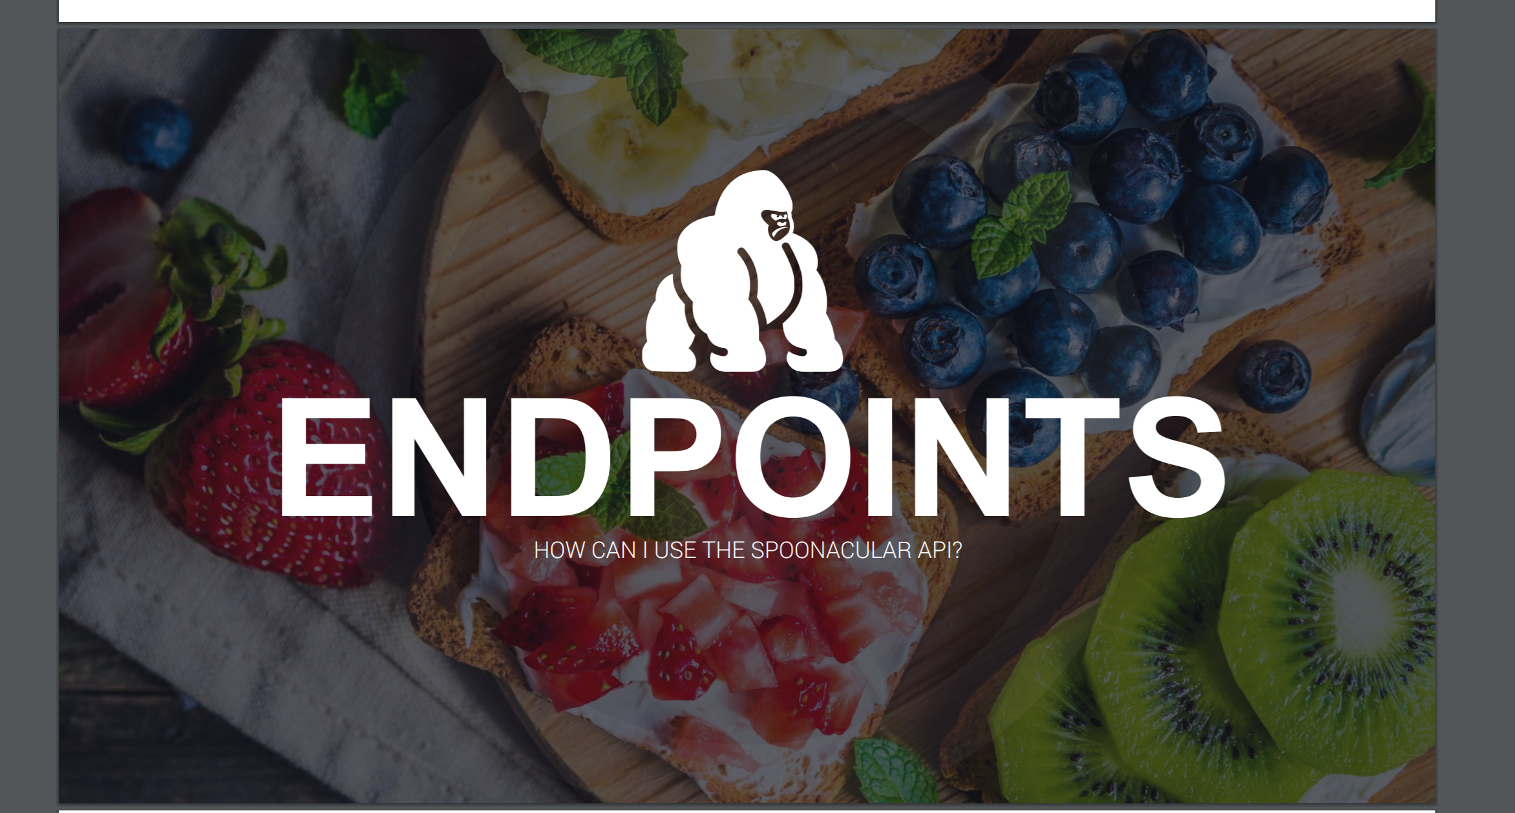

Landing Page

* Carousel
  + Some description on each slide

About Page

* Goals of the project
* Developer details

User Login Page (Model)

* User name / email
* Password

Pantry Page

• Visualize Ingredients

• Visualize ingredients of a recipe.

* Maintain available ingredients – (CRUD database)
* Select ingredients and go to Recipe page - 5

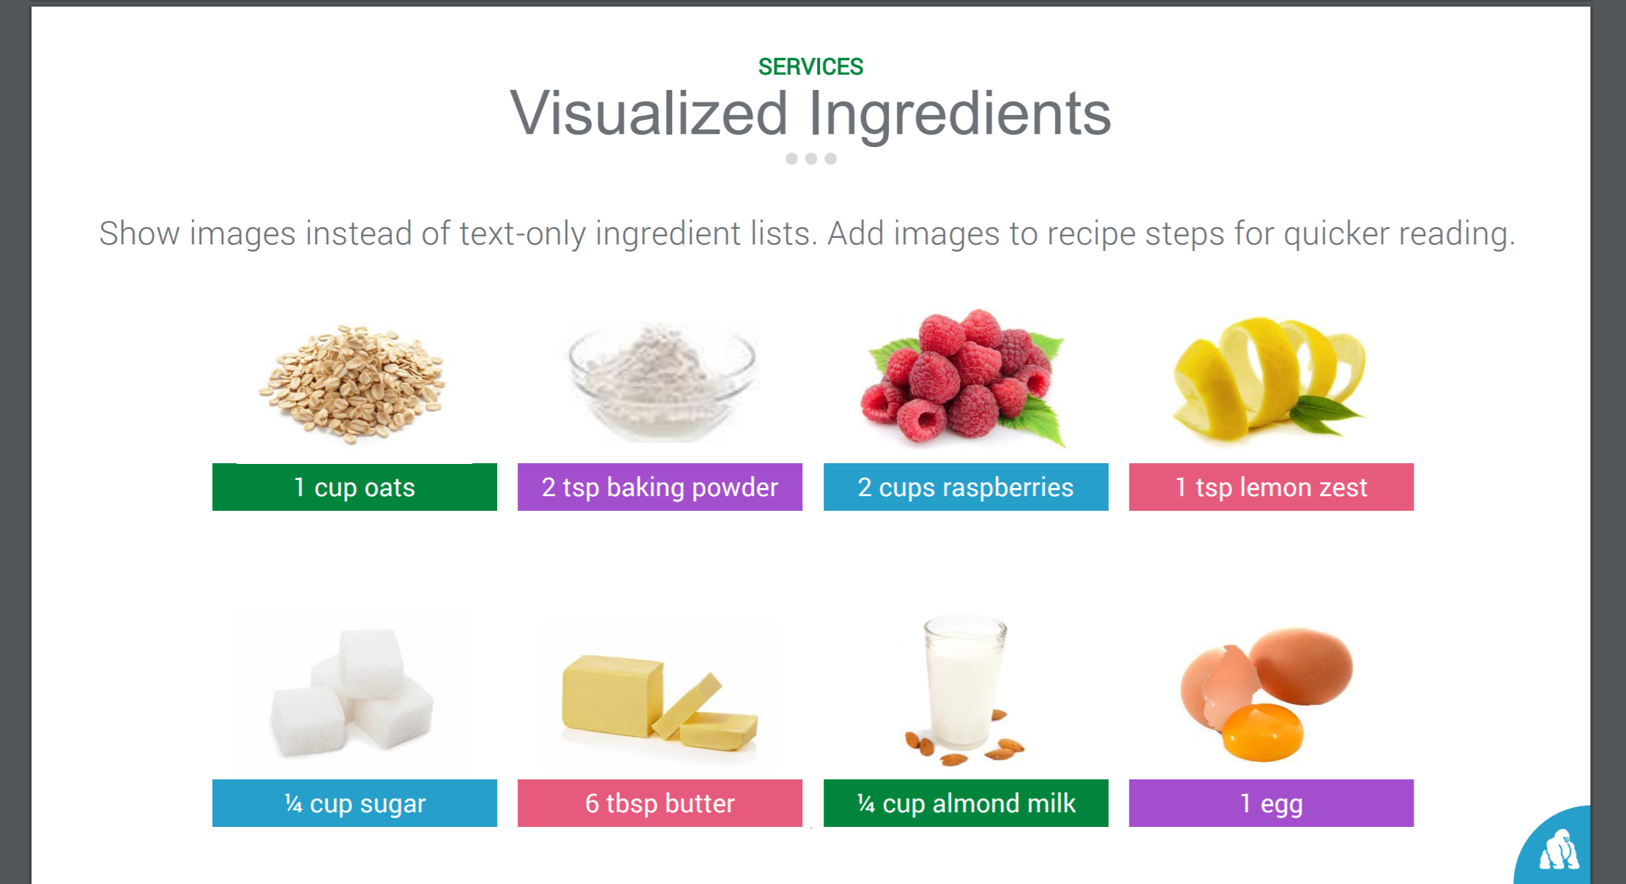

Based on Ingredients - Recipe

* Visualize ingredients of a recipe
* Auto complete the ingredients (if possible)

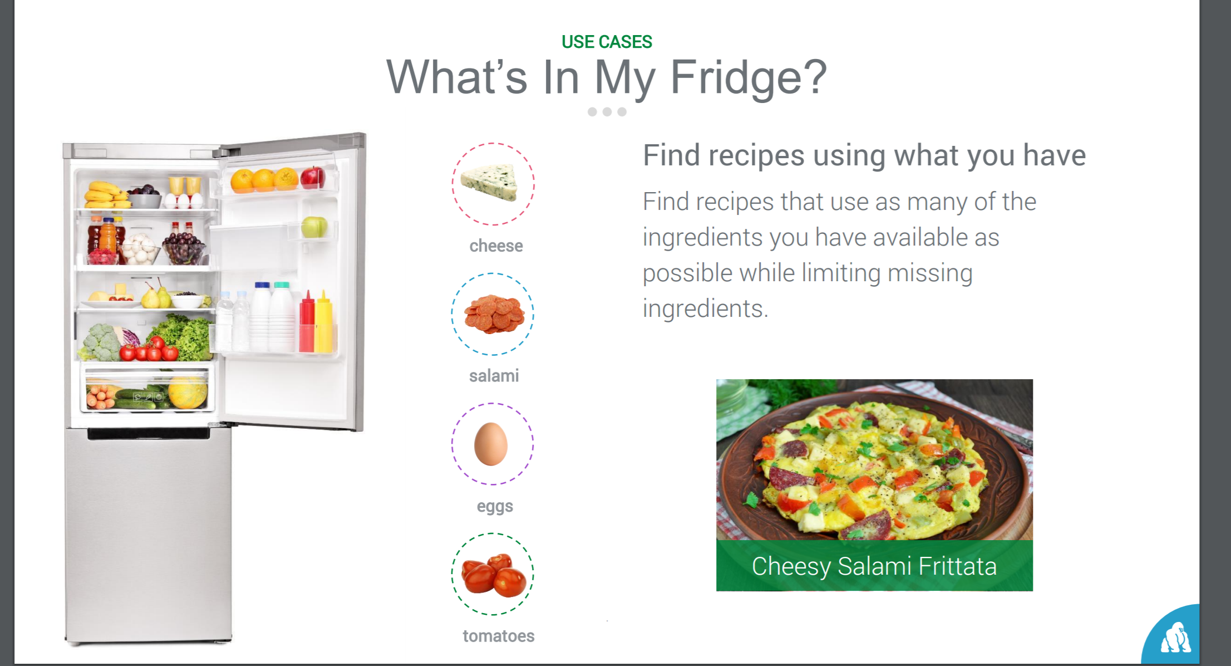 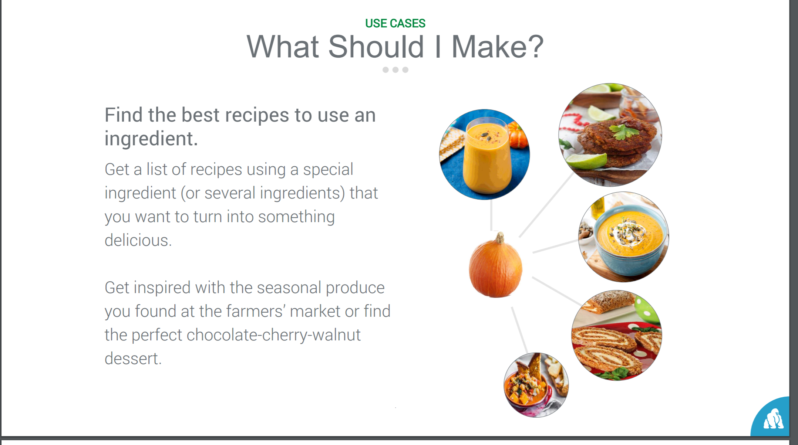

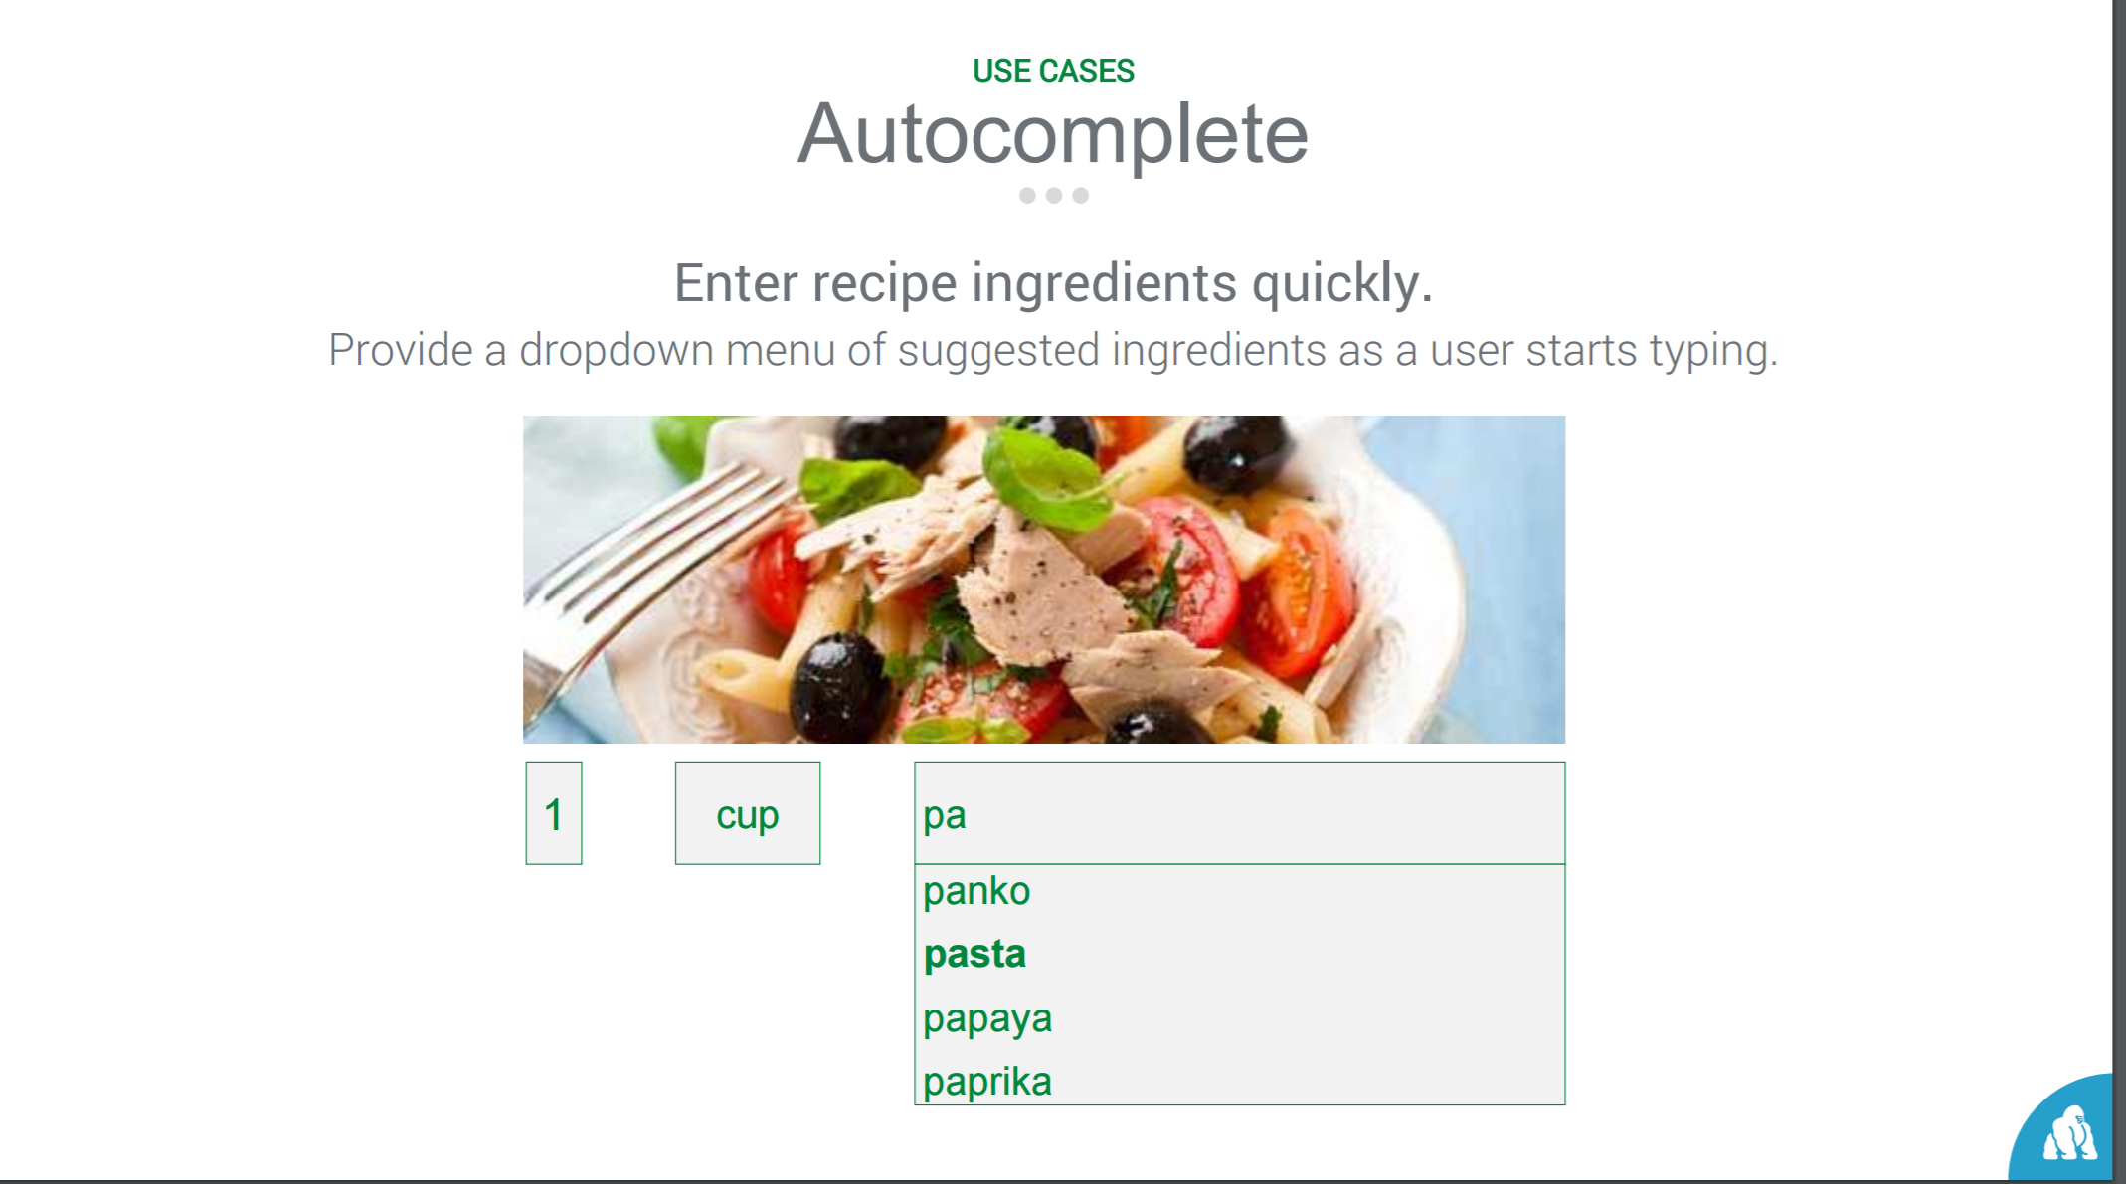

Recipe - How to Make

* Visualize the equipment used to make a recipe.
  + Step by step procedure (if possible)
    - Text
    - Picture
    - sound
  + Equipment & Ingredient picture
* Preparation time (if possible)
* Nutritional Information (thumb nail to modal)
* Add / Delete the recipe
* Recipe Card (printable - optional)

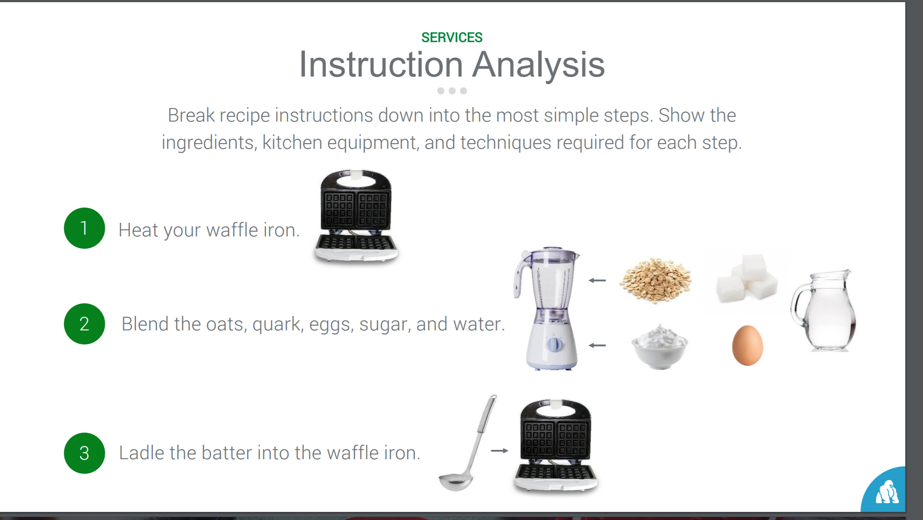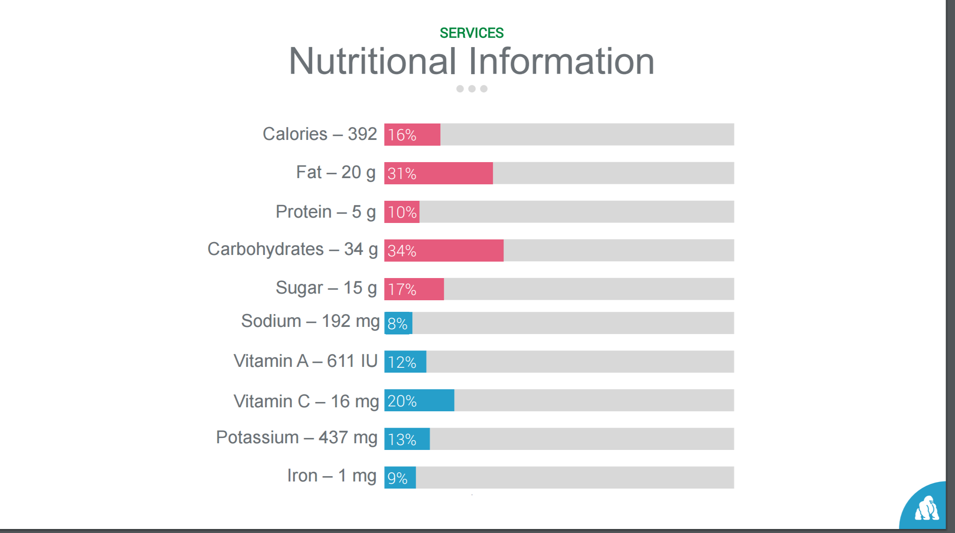 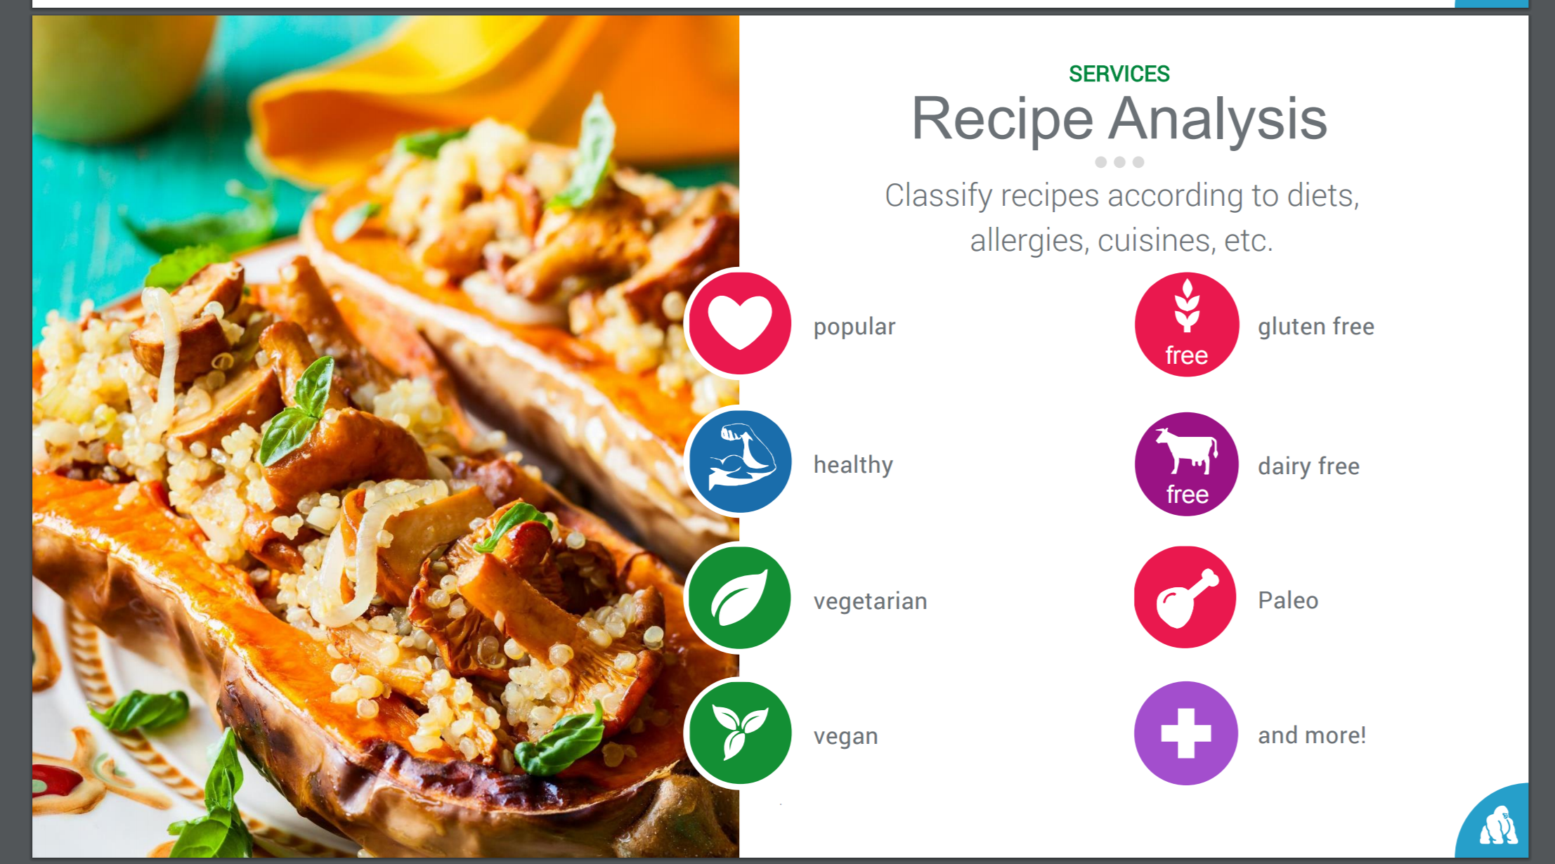 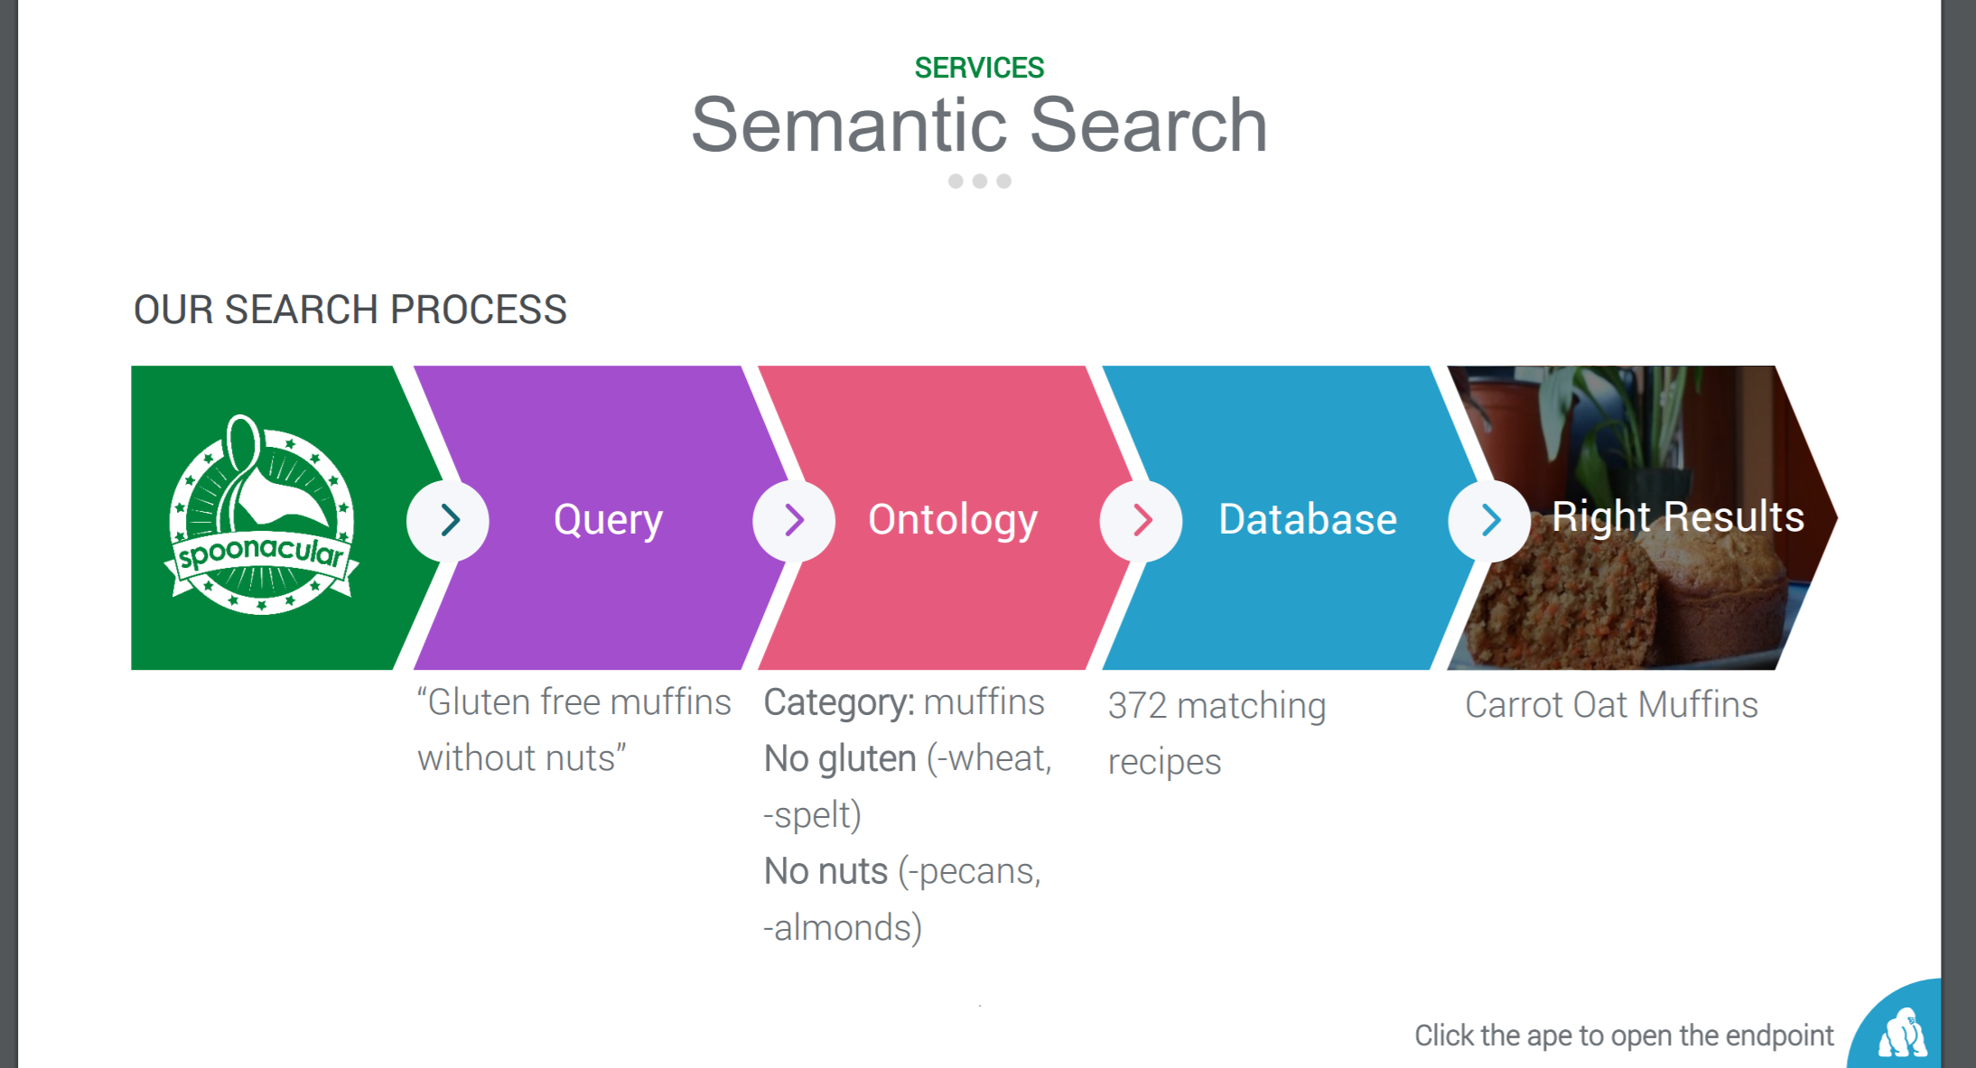

Grocery – Shop by Recipe

* Create grocery list.
* Provide links for online order placement to local stores (TBD)

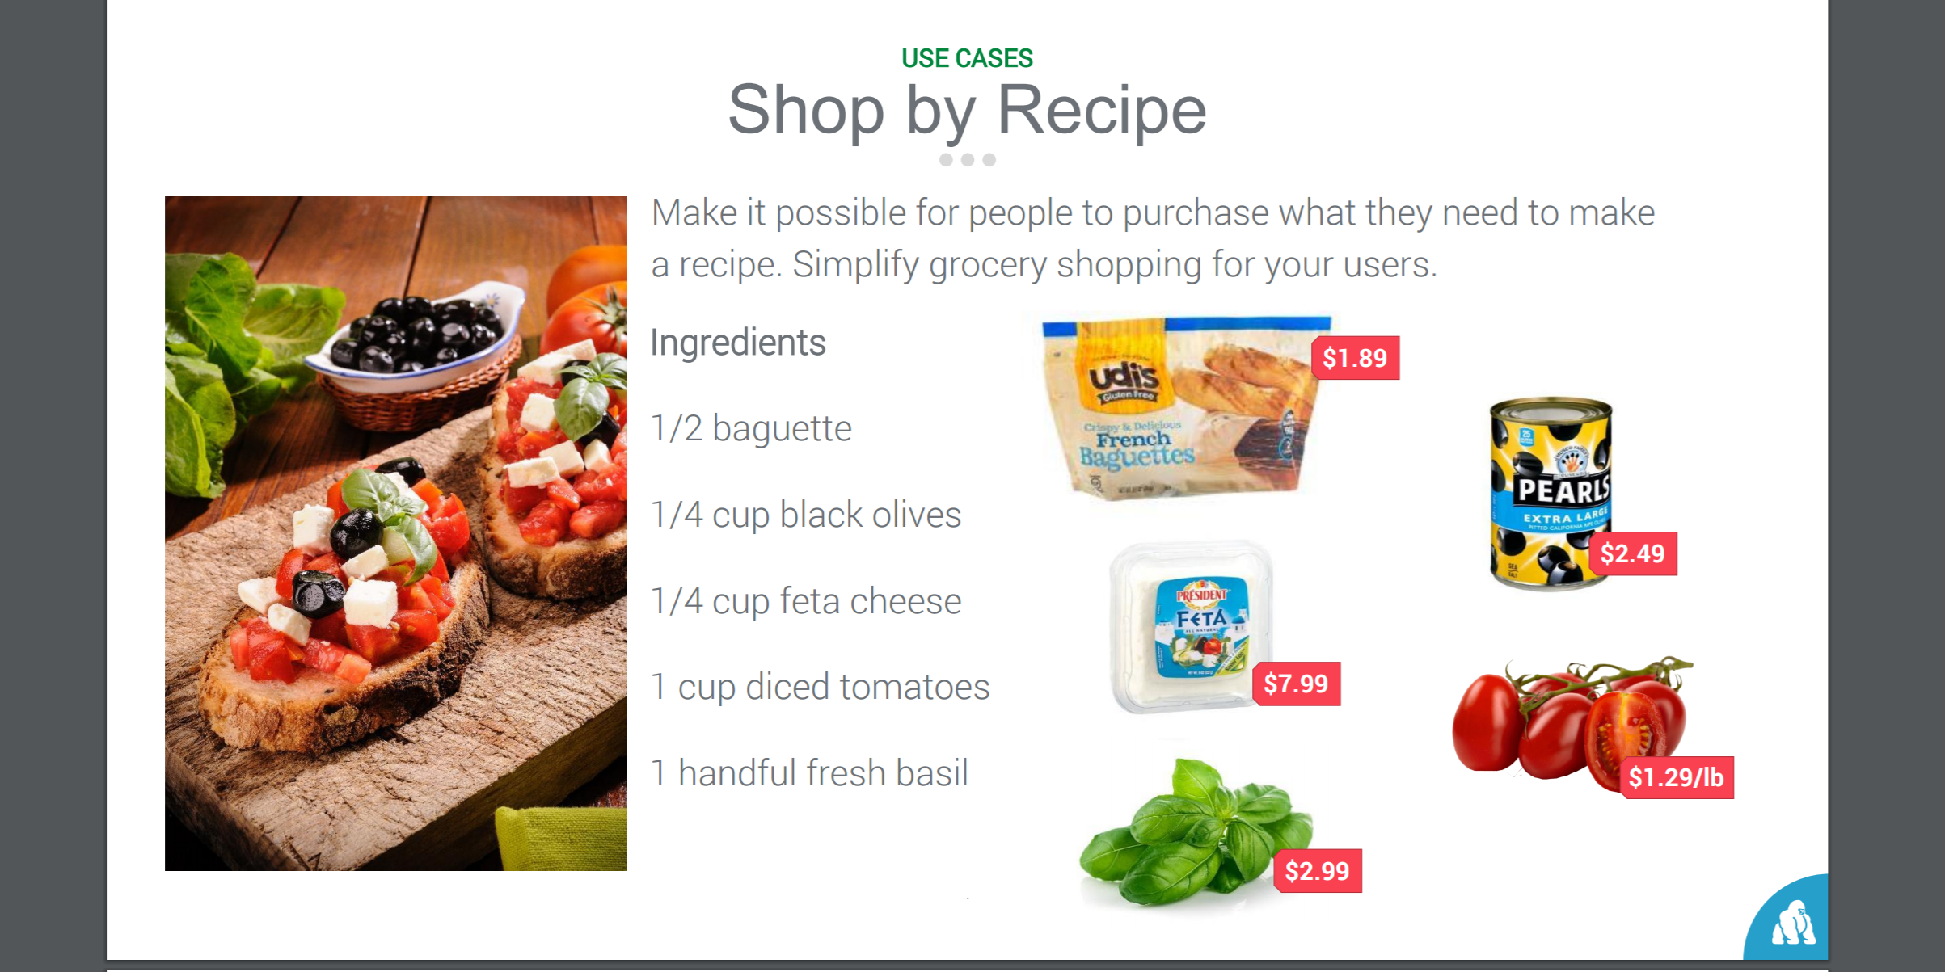

Meal Planning , Price Break Down & Smart Kitchen (TBD)

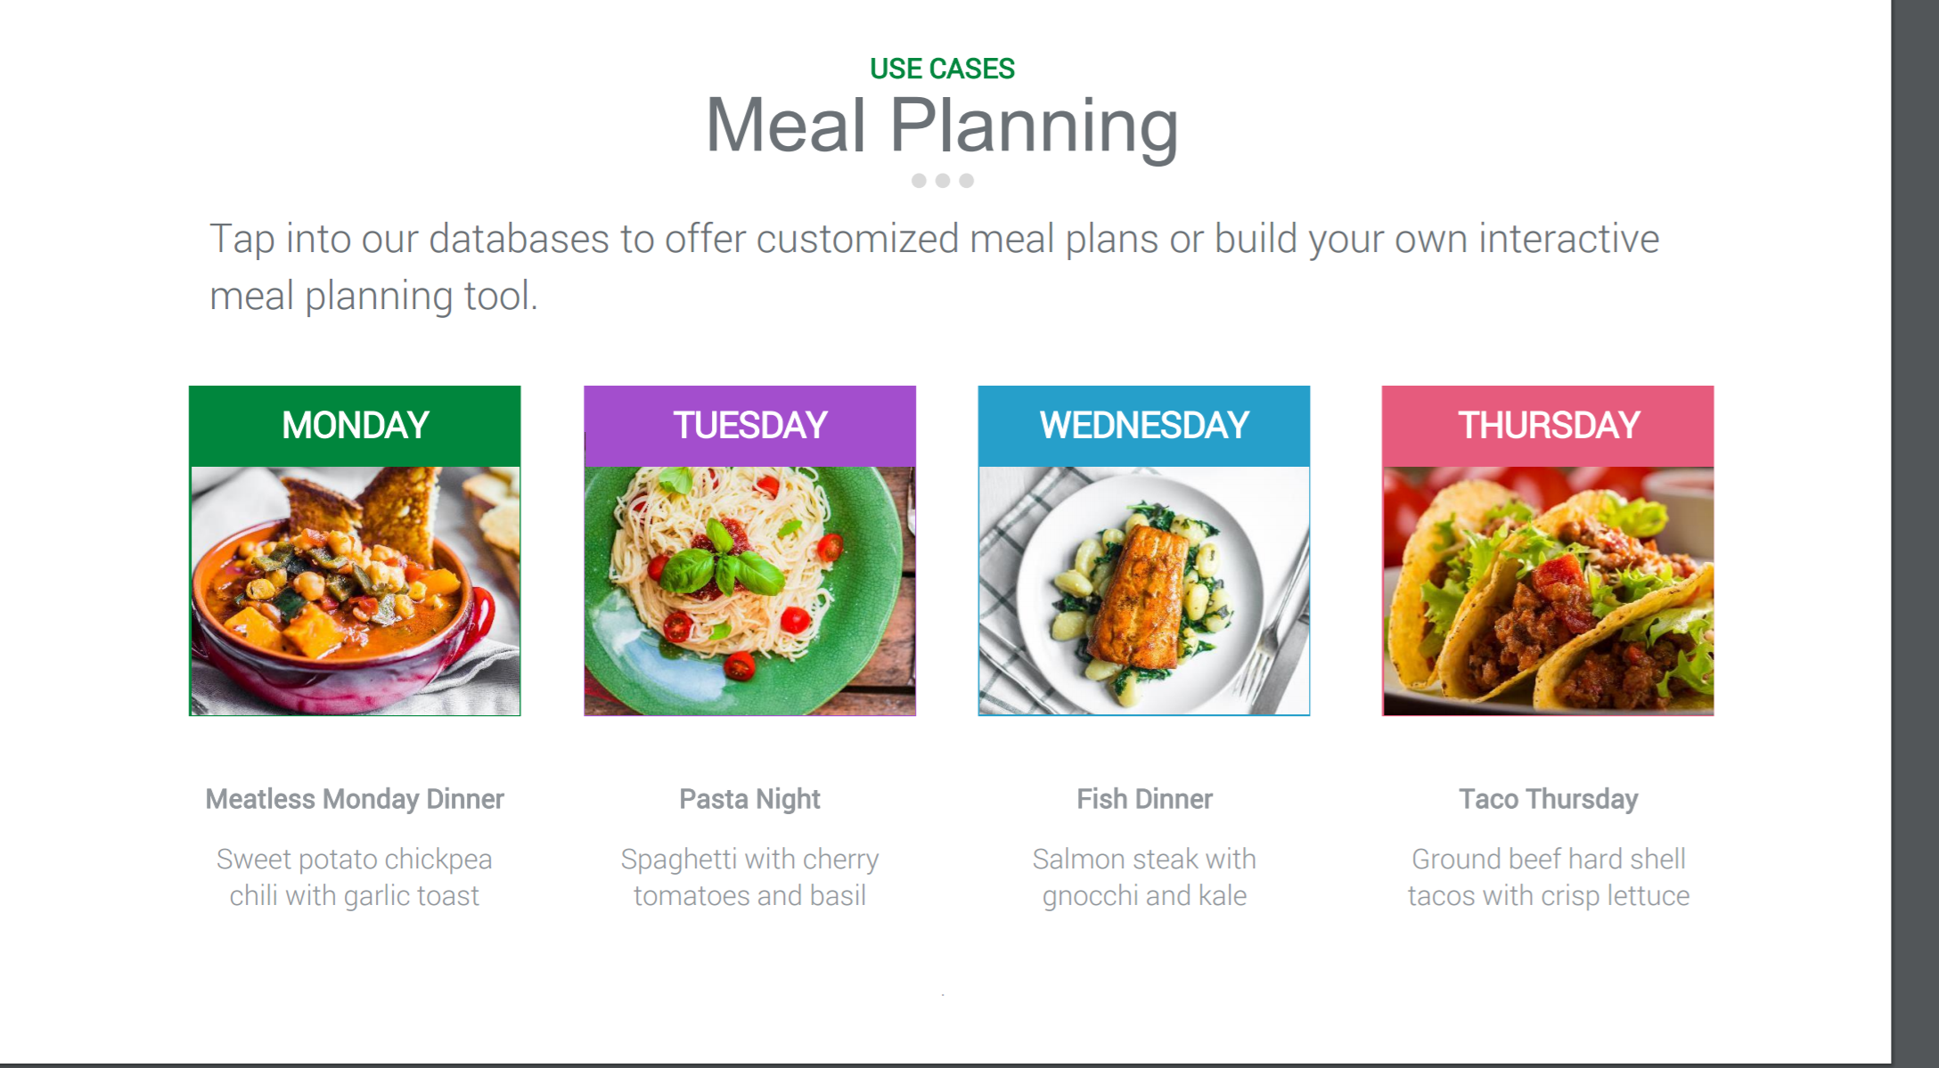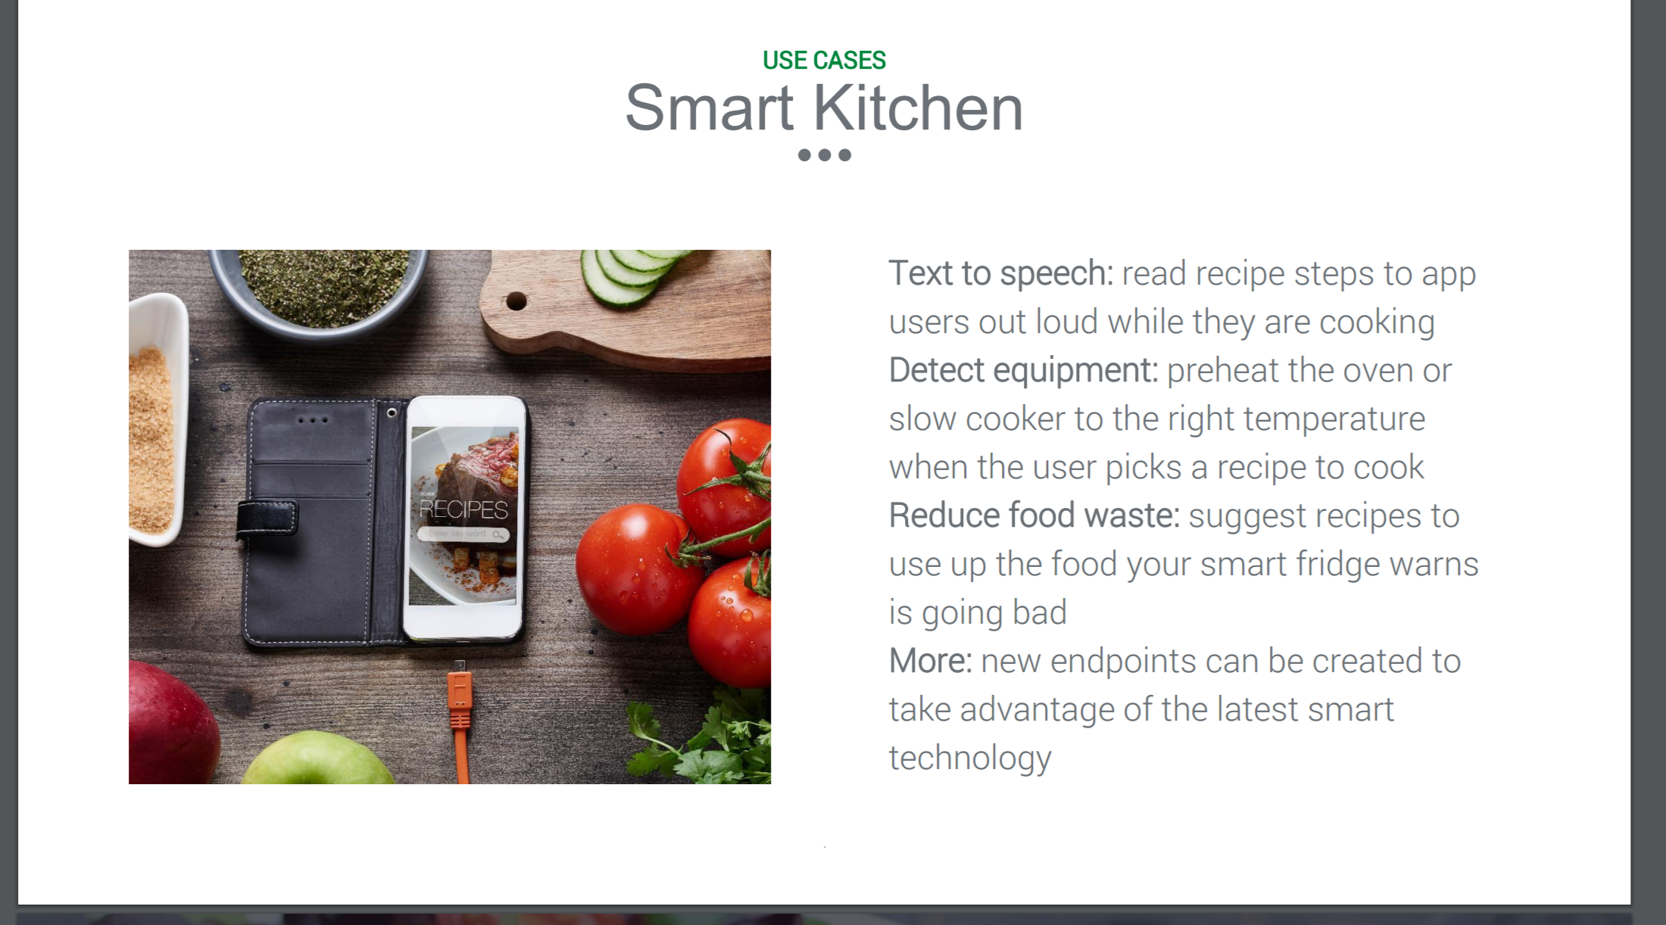

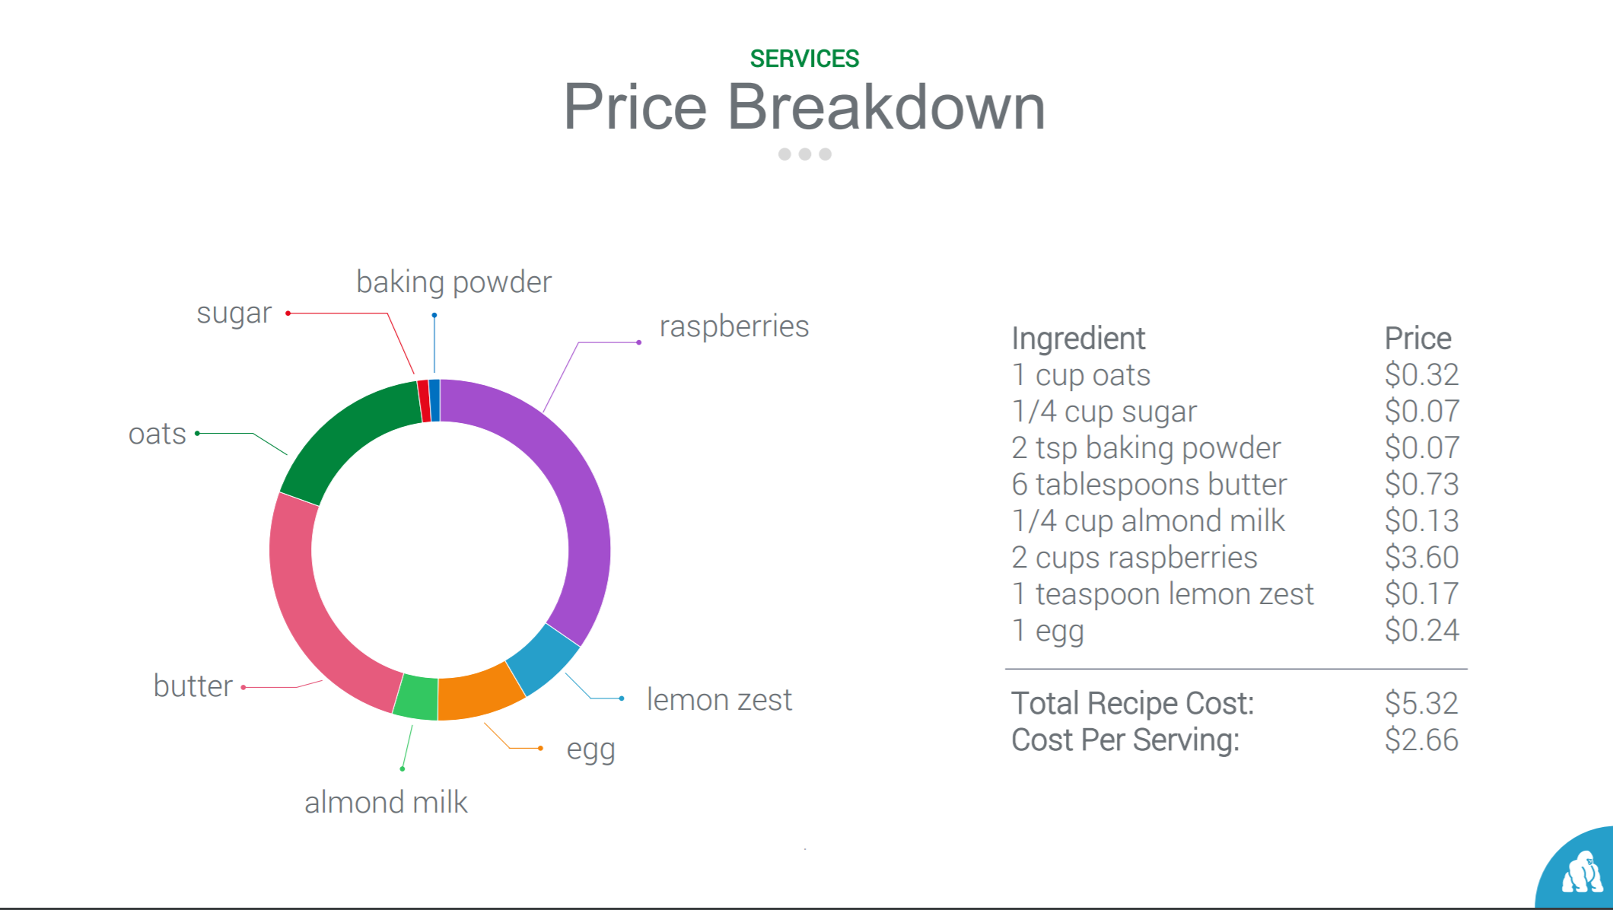

Working on finding the related APIs for the page

Pantry Page

• Select ingredients and display ingredients

• Adding new Ingredients

• Deleting Ingredients

• Go to recipes page based on the selected ingredients

Ingredient – Recipe Page

• Search for recipes based on the selected ingredients –limit 5 recipes

• Create Recipe Card

•

Recipe Page

• Search for recipes based on the entered ingredients/ name of the recipe

Contact Page

• Email for

Controllers

Recipe Controller

Attributes

• title: "Bacon Wrapped Jalapeno Popper Stuffed Chicken"

• source_url: "http://www.closetcooking.com/2012/11/bacon-wrapped-jalapeno-popper-stuffed.html"

• image_url: "http://static.food2fork.com/Bacon2BWrapped2BJalapeno2BPopper2BStuffed2BChicken2B5002B5909939b0e65.jpg"

• id

Methods

• Find recipe

o List of arguments

o Array of ingredient names

o Return list of recipes as array of json objects with the above recipe attributes

• Save recipe

Pantry Controller

To manage all the ingredient. Here is the json structure for the ingredients

name: string,

type: string,

id: number

• Available ingredients

o List of items

• Save recipe

Recipe Page

• Create Recipe Card

o Create a recipe card given a recipe.

Shopping list (TBD)

• Map Ingredients to Grocery Products

o Map a set of ingredients to products you can buy in the grocery store.

• Link to local grocery store

Nutrition & Diet Page (TBD)

• Match Recipes to Daily Calories

o Find multiple recipes that, when added up reach your daily caloric needs.

Cuisine Category

• Classify Cuisine

o Classify the recipe's cuisine.

• Classify Grocery Products (Batch)

• Given a set of product jsons, get back classified products.

• Summarize Recipe

• Summarize the recipe in a short text.

• Visualize Equipment

• Visualize the equipment used to make a recipe.

• Visualize Ingredients

• Visualize ingredients of a recipe.

• Visualize Nutrition

• Visualize a recipe's nutritional information.

• Autocomplete Ingredient Search

• Autocomplete a search for an ingredient.

• Autocomplete Recipe Search

• Autocomplete a partial input to possible recipe names.

• Find By Ingredients

• Find recipes that use as many of the given ingredients as possible and have as little as possible missing ingredients. This is a whats in your fridge API endpoint.

• Find By Nutrients

• Find a set of recipes that adhere to the given nutrient limits. All the found recipes will have macro nutrients within the calories, protein, fat, and carbohydrate limits.

• Find Similar Recipes

• Find recipes which are similar to the given one.

• Get Analyzed Recipe Instructions

• Get an analyzed breakdown of a recipe's instructions. Each step is enriched with the ingredients and the equipment that is used.